Journal of Biogeography
SUPPORTING INFORMATION
Time best explains global variation in species richness of amphibians, birds, and mammals.
Julie Marin and S. Blair Hedges

Appendix S1. Relationship between the dispersion of the diversification rate metric (DRr) and the dispersion of the evolutionary distinctiveness metric (EDr) (estimated by simulations).

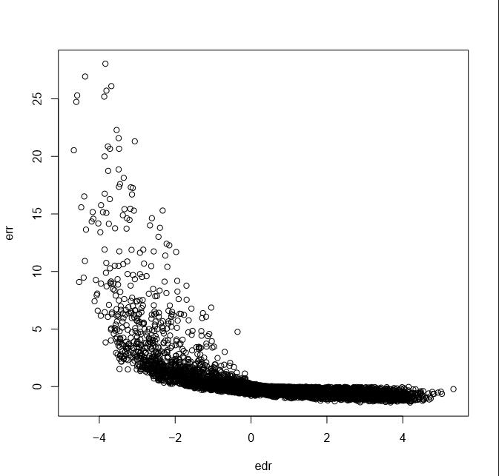
DRr
EDr

